AI Store Reality Engine
Optimizing E-commerce Stores for AI-Driven Decision-Making

Project Description
A platform that analyzes how AI systems interpret e-commerce products, identifies decision failures, and automatically optimizes content to improve AI-driven recommendations.
Team Name
- Neural Nexus

Prepared By
- Kharshavarthan N R
- Dharshini Saravanan

Hackathon
Kasparro Hackathon

Category
AI / E-commerce / SaaS Platform

Date
30/04/2026

“Bridging the gap between human-readable product content and machine-interpretable intelligence.”

Executive Summary
The rapid adoption of artificial intelligence in commerce is fundamentally changing how consumers discover and evaluate products. Instead of manually browsing e-commerce websites, users increasingly rely on AI systems to answer queries, compare products, and make recommendations.
However, most e-commerce platforms today are designed primarily for human interpretation, not for AI systems. Product descriptions are often unstructured, ambiguous, and optimized for marketing rather than clarity. As a result, AI systems frequently fail to correctly interpret product information, leading to missed recommendations and invisible revenue loss for merchants.
AI Store Reality Engine addresses this critical gap by enabling merchants to understand and optimize how their products are interpreted by AI systems. The platform simulates real-world AI decision-making using multiple AI personas, analyzes where and why products fail to be recommended, and provides actionable insights into improving product content.
A key capability of the platform is its ability to make AI behavior transparent. Through features such as Replay Mode, merchants can observe the step-by-step reasoning process of AI systems, identifying exactly where confusion or uncertainty occurs. This transforms AI from a black-box system into an explainable and diagnosable decision engine.
Beyond analysis, the platform introduces an Auto-Fix Engine that automatically transforms ambiguous product descriptions into structured, semantically rich, and machine-interpretable content. This significantly improves the ability of AI systems to extract features, align with user intent, and confidently recommend products.
The system also provides quantitative evaluation through an AI Trust Score, enabling merchants to measure how effectively their products are optimized for AI-driven environments. Additional insights such as Perception vs Reality, Conversion Kill Switch detection, and Intent Coverage analysis further enhance decision-making.
By bridging the gap between human-readable product content and machine-interpretable intelligence, AI Store Reality Engine enables businesses to adapt to the next evolution of commerce — where visibility and success are increasingly determined by AI systems rather than traditional interfaces.
Problem Statement
The rapid evolution of artificial intelligence is fundamentally transforming the way consumers interact with e-commerce platforms. Increasingly, users rely on AI systems to search, evaluate, and recommend products rather than manually browsing websites. These AI systems act as intermediaries, interpreting product data and making decisions on behalf of users.
However, the majority of existing e-commerce stores are not designed for this new paradigm.
Current product content is primarily optimized for human consumption — focusing on marketing appeal, brevity, and visual presentation. Descriptions often include vague or non-specific terms such as “high quality,” “premium,” or “best in class,” which may be persuasive for human users but lack the precision required for AI interpretation.
This creates a significant disconnect between how products are presented and how AI systems process information.
As a result:
- AI systems struggle to extract meaningful and structured attributes from product descriptions
- Important product features remain implicit rather than explicitly defined
- User queries cannot be accurately mapped to product capabilities
- AI systems default to low-confidence decisions and avoid recommending the product

This leads to a critical issue: products are not rejected because they are inadequate, but because they are not interpretable.

Real-World Example
Consider a product described as:
“Premium running shoes with excellent comfort.”
While this description may be sufficient for a human user, it fails to provide actionable information for an AI system.
If a user query is:
“Is this suitable for marathon training?”
The AI system requires specific attributes such as:
- durability
- cushioning
- weight
- long-distance performance
Since these attributes are not explicitly stated, the AI cannot confidently determine suitability and therefore avoids recommending the product.
Impact of the Problem
This limitation has direct business consequences:
- Reduced visibility in AI-driven recommendations
- Lower conversion rates despite product quality
- Inability for merchants to diagnose why products underperform
- Loss of potential revenue due to AI misinterpretation
Most importantly, these failures occur silently — merchants are not aware that their products are being filtered out at the AI decision layer.
Expanded Impact:
- Inconsistent product positioning across different AI systems, leading to unpredictable recommendation outcomes
- Reduced competitiveness in AI-first marketplaces where visibility is algorithmically determined
- Increased dependency on manual optimization and trial-and-error strategies, resulting in inefficiency and higher operational effort

Core Problem Statement
E-commerce platforms are optimized for human interaction, while modern purchasing decisions are increasingly influenced by AI systems that require structured, explicit, and interpretable product data.
Solution Overview
AI Store Reality Engine is designed to bridge the gap between human-oriented product content and AI-driven decision-making systems.
The platform provides a comprehensive framework that enables merchants to simulate, analyze, and optimize how their products are interpreted by AI systems. By combining multi-agent simulation, explainable AI workflows, and automated content optimization, the system transforms opaque AI behavior into a transparent and actionable process.
At its core, the solution focuses on three key capabilities:
1. AI Behavior Simulation
The platform simulates real-world AI decision-making using multiple AI personas, such as budget-conscious, premium-focused, and risk-averse agents.
These agents evaluate products against realistic user queries, enabling merchants to understand how AI systems interpret product data under different contexts and decision criteria.
2. Decision Transparency and Analysis
AI Store Reality Engine provides a structured view of how decisions are made through its Replay Mode and analysis modules.
Instead of treating AI as a black box, the system exposes each stage of the evaluation pipeline — including data parsing, feature extraction, query alignment, and confidence assessment.
This allows merchants to pinpoint exactly where and why a product fails to meet AI decision thresholds.
3. Automated Content Optimization
The Auto-Fix Engine transforms unstructured and ambiguous product descriptions into semantically rich, machine-interpretable formats.
By introducing explicit attributes, defined use-cases, and structured signals, the system improves AI interpretability and enhances the likelihood of product recommendation.
This removes the need for manual optimization and ensures consistent improvement across product listings.
End-to-End Workflow
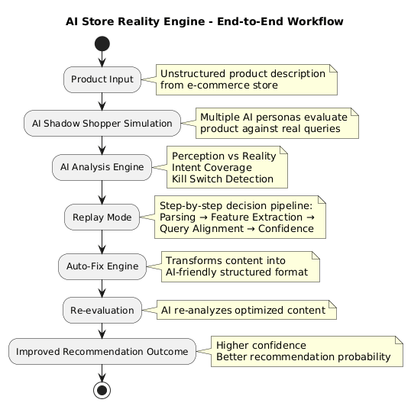
Key Value Proposition
AI Store Reality Engine enables merchants to:
- Understand how AI systems perceive their products
- Identify hidden failure points in AI decision-making
- Automatically improve product content for better interpretability
- Increase the likelihood of being recommended in AI-driven environments
System Architecture Diagram
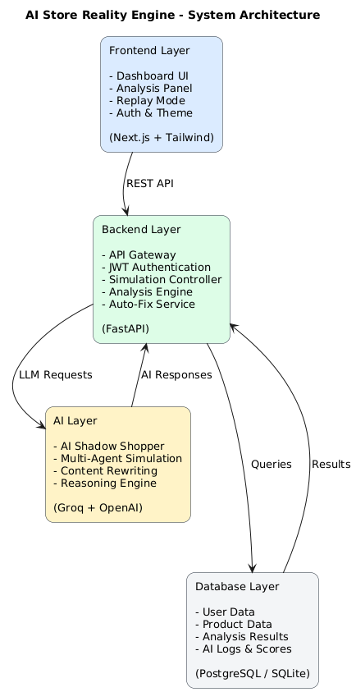

Core Features
AI Store Reality Engine is built around a set of advanced AI-driven modules that simulate, analyze, and optimize how products are interpreted by AI systems. Each feature is designed to address a specific failure point in AI-driven decision-making.
AI Shadow Shopper (Multi-Agent Simulation)
Overview
The AI Shadow Shopper simulates how different AI-driven buyer personas evaluate a product in real-world scenarios.
Functionality
- Creates multiple AI agents such as:
  - Budget-conscious buyer
  - Premium-focused buyer
  - Risk-averse (skeptical) user
- Each agent processes the same product independently
- Evaluates product against realistic user queries
Technical Insight
- Uses LLM-based reasoning to simulate decision-making
- Each agent operates with a different evaluation bias
- Generates diverse interpretations of the same product
Value
- Reveals how different AI systems may interpret the product
- Identifies inconsistencies in recommendation behavior
- Provides a realistic approximation of AI-driven commerce environments
Replay Mode (Decision Transparency Engine)
Overview
Replay Mode exposes the internal decision pipeline of AI systems in a structured, step-by-step manner.
Functionality
- Breaks down AI reasoning into stages:
  - Data parsing
  - Feature extraction
  - Query alignment
  - Confidence evaluation
- Displays where decision failure occurs
Technical Insight
- Converts black-box AI outputs into interpretable steps
- Tracks confidence levels across stages
- Enables traceability of AI decisions
Value
- Provides explainability for AI behavior
- Helps merchants understand why a product is not recommended
- Enables precise debugging of content-related issues
Auto-Fix Engine (AI Optimization Layer)
Overview
The Auto-Fix Engine automatically transforms product content into AI-optimized, machine-interpretable formats.
Functionality
- Rewrites product descriptions using AI
- Adds:
  - Explicit attributes
  - Structured features
  - Clear use-case definitions
- Eliminates vague or ambiguous terms
Technical Insight
- Uses LLM-based content generation
- Enhances semantic clarity and feature extraction
- Improves alignment with query intent
Value
- Reduces manual effort in content optimization
- Improves AI interpretability instantly
- Directly increases recommendation probability
AI Analysis Engine (Insight Generation)
Overview
Provides deep analytical insights into how AI interprets and evaluates product content.
Key Components
Perception vs Reality
- Compares intended product positioning with AI interpretation
- Identifies misalignment in branding and messaging
Conversion Kill Switch Detection
- Detects critical missing information:
  - Specifications
  - Use-case clarity
  - Trust signals
- Highlights factors that block AI recommendations
Intent Coverage Analysis
- Evaluates whether product content answers real user queries
- Identifies gaps in query-response alignment
Technical Insight
- Combines NLP analysis with structured evaluation metrics
- Maps product content against real-world query patterns
Value
- Provides actionable insights beyond surface-level analysis
- Helps merchants optimize for real user intent
- Bridges gap between content and AI expectations
AI Trust Score (Quantitative Evaluation)
Overview
A scoring system that quantifies how effectively a product is optimized for AI-driven recommendations.
Functionality
- Generates a score based on:
  - Clarity
  - Completeness
  - Consistency
  - Interpretability
- Tracks improvement before and after optimization
Technical Insight
- Aggregates multiple evaluation signals into a unified metric
- Reflects confidence level of AI systems
Value
- Provides measurable performance indicator
- Enables benchmarking and tracking improvements
- Simplifies decision-making for merchants

Real-World Use Case
To validate the effectiveness of AI Store Reality Engine, we consider a practical e-commerce scenario involving a commonly sold product — running shoes.

Initial Product Context
A merchant lists a product with the following description:
“Premium running shoes with excellent comfort and modern design.”
While this description is appealing and concise for human users, it lacks explicit, structured, and measurable attributes required for AI interpretation.

User Query Scenario
Consider a typical AI-driven query:
“Is this suitable for marathon training?”
To accurately respond, an AI system must identify specific attributes such as:
- Long-distance durability
- Cushioning support
- Breathability
- Weight and performance efficiency
However, these attributes are not explicitly defined in the product description.

AI Evaluation (Before Optimization)
Using the AI Shadow Shopper module:
- Multiple AI agents evaluate the product independently
- Each attempts to align the product with the query
- Due to missing signals, all agents exhibit low confidence
Outcome
The AI system does not recommend the product.

Failure Analysis (Replay Mode)
Replay Mode reveals the internal reasoning breakdown:
- Product data is successfully parsed
- Feature extraction is incomplete due to vague descriptions
- Query alignment fails due to missing performance attributes
- Confidence level drops below recommendation threshold
Key Insight
The product is not rejected due to poor quality, but due to insufficient interpretability.

Content Optimization (Auto-Fix Engine)
The Auto-Fix Engine enhances the product description by introducing structured and explicit information.
Before Optimization
“Premium running shoes with excellent comfort”
After Optimization
“Lightweight running shoes with breathable mesh upper, cushioned sole, and enhanced durability, specifically designed for long-distance running and marathon training.”

AI Re-evaluation (After Optimization)
The optimized content is processed again by AI systems:
- Feature extraction improves significantly
- Strong semantic alignment with the user query is established
- Confidence levels increase
Outcome
The product is successfully recommended by the AI system.

Technical Implementation
AI Store Reality Engine is designed using a modular and scalable architecture that integrates modern web technologies with AI-driven processing. The system is divided into four primary layers: frontend, backend, AI services, and database.
Frontend Layer
The frontend is developed using Next.js with a modern UI framework.
Key Responsibilities
- User authentication and dashboard interface
- Product input and analysis interaction
- Visualization of AI outputs (Replay Mode, scores, insights)
- Responsive UI with light/dark mode support
Technical Details
- Component-based architecture
- API communication via REST endpoints
- State management for real-time updates

Backend Layer
The backend is built using FastAPI, acting as the core processing layer.
Key Responsibilities
- API routing and request handling
- Business logic execution
- AI workflow orchestration
- Integration with external AI services
Core Modules
- Authentication service (JWT-based)
- Simulation controller (AI Shadow Shopper)
- Analysis engine (insight generation)
- Auto-Fix service (content optimization)

AI Layer (Groq + OpenAI)
The AI layer powers all intelligent features of the system.
Usage
- Groq API: Fast inference for real-time simulation and evaluation
- OpenAI API: Advanced reasoning and content rewriting
Key Capabilities
- Multi-agent simulation (Shadow Shopper)
- Natural language understanding
- Content transformation and optimization
- Decision reasoning and evaluation

Database Layer
The system uses PostgreSQL (or SQLite for local development) for persistent storage.
Stored Data
- User accounts and authentication data
- Product information
- Analysis results and reports
- AI-generated scores and logs

System Workflow (Technical Perspective)
- User submits product data via frontend
- Backend processes request and triggers AI simulation
- AI layer evaluates and generates insights
- Results are stored in database
- Optimized content is generated via Auto-Fix Engine
- Re-evaluation is performed and results are displayed

Scalability & Design Considerations
- Modular architecture allows independent scaling of components
- AI services are decoupled from backend logic
- REST API design ensures flexibility and integration capability
- Database supports tracking and historical analysis

Key Technologies Used
- Frontend: Next.js, Tailwind CSS
- Backend: FastAPI (Python)
- AI Services: Groq API, OpenAI API
- Database: PostgreSQL / SQLite
- Authentication: JWT-based system

- AI Store Reality Engine addresses a fundamental shift in e-commerce, where AI systems are increasingly responsible for product discovery and decision-making. While most platforms remain optimized for human users, this project highlights the growing need to make product data interpretable for AI systems.
- Through a combination of AI simulation, decision transparency, and automated content optimization, the platform enables merchants to understand how their products are evaluated by AI and take actionable steps to improve outcomes.
- By transforming ambiguous product descriptions into structured, machine-interpretable content, the system directly enhances AI confidence and recommendation likelihood without altering the product itself.
- The key contribution of this project lies in making AI behavior observable and controllable — converting a traditionally opaque process into a measurable and optimizable workflow.

